**Create your own CYOA Design**

**What is your game theme?**

Medieval

**What is an image that sums up your game theme?**

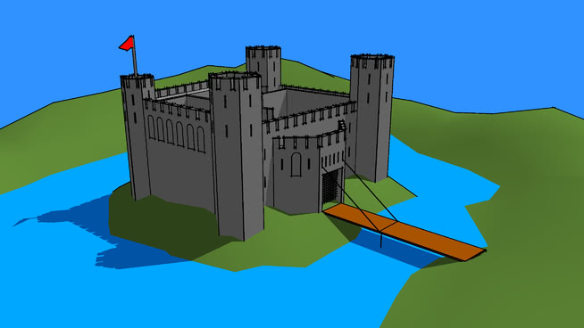

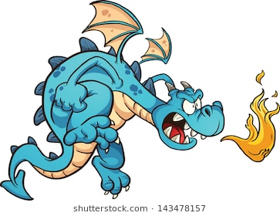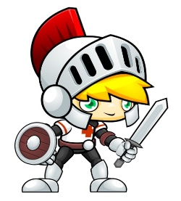

**Who is the player?**

The clumsy knight fleeing back to the castle

**What is the goal?**

To run over the drawbridge before it is raised and the dragon is able to kill the clumsy knight

**StateMachine**

